**Reception teaching assistant**

Temporary until 31/08/2023 initially (to provide additional support to pupils with SEND)

Part Time (0.4) 8.30-4.00pm term time only Thursday & Friday)

Start date: 5th September 2022

St. Andrew’s CE Infant school is a two-form entry Church of England Infant school for pupils aged 4-7 years and currently has 180 pupils on roll.

We wish to appoint a highly motivated, enthusiastic and dedicated teaching assistant who is fully supportive of our Christian ethos.

We are looking for someone who:

* Is child centred;
* Is an effective team member;
* Shows initiative and can work with high levels of independence;
* Has good communication and interpersonal skills;
* Is adaptable and has ambition, flexibility and good humour;
* Has a positive outlook and is calm under pressure;
* Can work creatively in partnership with pupils, families, staff, governors and the wider community;
* Is supportive of our Christian ethos
* Has experience of supporting pupils with SEND

In return we can offer:

* A school with a strong Christian ethos, ambition and good team work;
* Friendly, well behaved, caring and motivated children who are eager to learn;
* An enthusiastic and committed staff;
* A mutually supportive network of schools (Compass Network) to work with;
* A commitment to your professional development.

Informal visits are warmly welcomed. Please telephone the school to make an appointment.

Closing date: 12 noon Friday 12th August

Interviews: w.b. Monday 15th August

**Additional Information**

This school is committed to safeguarding and promoting the welfare of children and young people and expects all staff and volunteers to share this commitment. This post is subject to an enhanced CRB disclosure.

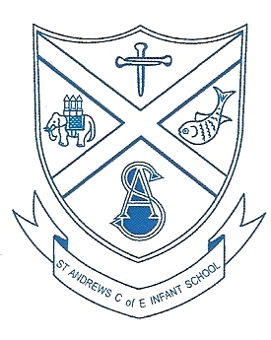

**St. Andrew’s C of E Infant School**

Church Lane,

Eastern Green,

Coventry.

CV5 7BX

Tel: 02476 466309

Fax: 02476 460752

Email: headteacher@st-andrews.coventry.sch.uk