**Henley Green Primary School**

***‘It’s our place to shine’***

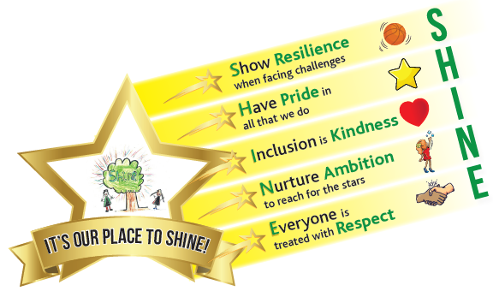

**Job Purpose**

To work as part of a team to:

* Promote high quality learning for all children.
* Provide care and supervision of children.
* Foster and support children to participate in the full life of the school.
* Help children to become independent learners.
* Raise attainment.

## Professional Attributes

* Have high expectations of children with a commitment to helping them fulfil their potential.
* Establish fair, respectful, trusting, supportive and constructive relationships with children and young people.
* Demonstrate the positive values, attitudes and behaviour we expect from children.
* Communicate effectively and sensitively with children, colleagues, parents and carers.
* Recognise and respect the contribution that parents and carers can make to the development and wellbeing of children.
* Demonstrate a commitment to collaborative and cooperative working with colleagues.
* Improve your own knowledge and practice (e.g. responding to advice and feedback).

## Professional Knowledge and Understanding

* Understand the key factors that affect children and young people's learning and progress.
* Know how to contribute to effective personalised provision by taking practical account of diversity.
* Have sufficient understanding of their area(s) of expertise to support the development, learning and progress of children.
* Understand the objectives, content and intended outcomes for the learning activities in which they are involved.
* Know how to support learners in accessing the curriculum in accordance with the special educational needs (SEN) code of practice and disabilities legislation.
* Know how other frameworks, that support the development and well‐being of children and young people, impact upon their practice.

## Planning and Expectations

* Use their area(s) of expertise to contribute to the planning and preparation of learning activities.
* Plan how they will support the inclusion of the children and young people in the learning activities.
* Contribute to the selection and preparation of resources suitable for children and young people's interests and abilities.

## Teaching and Learning Activities

* Use effective strategies to promote positive behavior.
* Advance learning, when working with individuals and small groups.
* Organise and manage learning activities in ways which keep learners safe.

## Monitoring and Assessment

* Monitor learners' responses to activities and modify approaches accordingly.
* Monitor learners' progress in order to provide focused support and feedback.
* Support the evaluation of learners' progress using a range of assessment techniques.
* Contribute to maintaining and analysing records of learners' progress.

|  |  |
| --- | --- |
| 1234567 | **Person Specification** |

|  |  |  |  |
| --- | --- | --- | --- |
|  |  |  |  |
| **Job Title:** | Teaching Assistant | **Job Number:** |  |
| **Directorate:** | Children, Learning and Young People | **Post Number:** |  |
| **Service:** | Services for Schools | **Grade:** | Grade 3 |
| **Location:** | Henley Green Primary School | | |

|  |  |
| --- | --- |
|  | **Job Requirements** |
| **Knowledge:** | * Understanding of relevant codes of practice and legislation. * Experience and understanding of child development and learning. * Training in relevant learning strategies * (Desirable not essential) Knowledge of RWI |

|  |  |
| --- | --- |
| **Skills and**  **Abilities:** | * Able to effectively use IT and use of other equipment * Ability to relate well to children and adults. * Able to work constructively as part of a team. * Ability to self evaluate learning needs. |

|  |  |
| --- | --- |
| **Experience:** | Experience of working with children of relevant age or with specific special needs. |

|  |  |
| --- | --- |
| **Educational:** | * Excellent literacy and numeracy skills |

|  |  |
| --- | --- |
| **Special Requirements:** | * This post is exempt from the provisions of the Rehabilitation of Offenders Act 1974. A Criminal Record Disclosure will be required prior to appointment. * This school is committed to safeguarding and promoting the welfare of children and young people and expects all staff and volunteers to share this commitment. |