  St Bartholomew’s CofE Academy  Class Teacher |     
   | 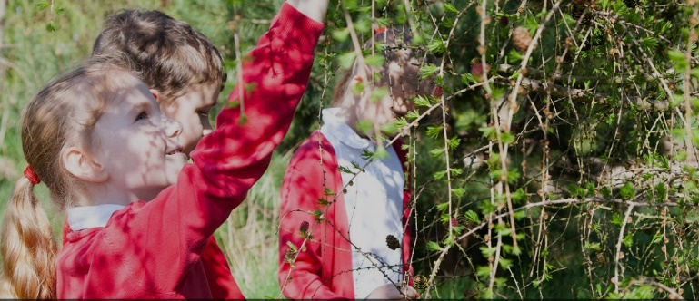
Are you the right person for this key role within the  academy and community? | Class Teacher  Current grade and salary:  TMS 1-6 £28,000-£38,810  Start Date:  1st January 2024  Academy Visit:  Please see the contact details below  Closing Date:  Monday, 02 October 2023  Interview Date:  W/C Monday 9th October 2023
The Diocese of Coventry Multi Academy Trust is looking to appoint a resourceful and highly effective Teacher who is both passionate about making a difference for children in their care and committed to developing St Bartholomew’s Church of England Academy.

The Leadership Team of this academy has the opportunity to work with the Trust and other church school partners to transform the educational experiences of the children of Coventry.
Are you:
- Able to work with individuals & groups, work part of a team to provide a happy & safe environment?
- Highly motivated with a positive attitude?
- Able to support & motivate children to flourish & develop?
- Able to work effectively with colleagues and parents?
- Proficient with IT – we use flipchart planning to reduce workload.
Do you:
- Value high-quality professional development? – we offer an extensive MAT CPD programme.
- Enjoy working as part of a team to improve outcomes for children?

If so, please apply, we would love to meet you!

For an appointment to visit the school please contact Teresa Shannon on 02476 458960. Applications to Clusterhr@covmat.org
For full information please see www.covmat.org/vacancies or email clusterhr@covmat.org
St Bartholomew’s CofE Academy, Bredon Avenue, Coventry, CV3 2LP

