

Abercorn Road

Coventry

CV5 8ED

Tel: 024 7667 5836

25th March 2022

Dear Applicant

On behalf of the governing body of All Souls’ Catholic Primary School I thank you for your interest in the position of Headteacher of our school.

All Souls’ Catholic Primary School is a one form entry voluntary aided school located in the Chapelfields area of Coventry. The school serves a residential area made up of a mixture of rented and owner occupied occupation. We are a fully inclusive school with an age range of three years to 11 years. We have a 26 place nursery on site.

This vacancy arises following the retirement of our long serving and respected Headteacher last year.  Following a brief period of interim arrangements, the governors are now in a position to appoint to the substantive role.

All Souls is a popular school that has an excellent reputation within the community. It was rated ‘Good’ following the last Ofsted inspection in 2019 with feedback that included, “a school where pupils receive the very highest quality of education and where equal importance is also applied to pupils personal and mental well-being”.

The school has strong links with our Parish Church of the Precious Blood and All Souls with children joining in Mass with the parish community on a regular basis. Father Paul Burch, our Parish Priest, is a regular visitor to the school. We have established strong links with the parish and continue to improve our contribution as a school to the parish and wider community.

Our mission statement is” Christ is our light” which underpins the teaching, learning and life opportunities that are given to our children. Our ambition is that the Catholic life of our school is rich and meaningful from the first entry to school and until our pupils leave us at the end of Key Stage 2.

Governors wish to appoint a practising Catholic who whilst being an innovative and inspirational leader will, like our previous Headteacher, be as “determined and resolute” (as recognised by Ofsted) to continue the development of a curriculum which is rich and challenging. You will have to meet the continuing requirement to provide a school environment that is safe and secure, stimulating and memorable, where each child feels included and opportunities are provided so pupils can meet the expectation that they fulfil their potential.

The successful candidate will have a proven track record of creating a united and supportive team. You will bring the values of the Gospel to lead the school community by example in addition to maintaining high standards and progress the school forward in line with our vision for the future.

Candidates should be aware of the Archdiocesan vision for education and strategy of all Catholic schools becoming secured within a multi academy family of schools. The successful candidate will work with governors to constructively engage with Catholic Senior Executive Leaders over time to ensure that the strong ethos, community spirit and identity of All Souls school is retained.

<https://www.bdes.org.uk/coventry-and-north-warwickshire-mac.html>

Thank you again for your interest in the position of Headteacher at our school. We would encourage and warmly invite you to visit us as part of the application process.

Please contact Linsey Rae, School Business Manager (email: [linsey.rae@allsoulsschool.co.uk](mailto:linsey.rae@allsoulsschool.co.uk) ) if you would like discuss the post with the Chair of Governors or to arrange an informal visit on 5th or 7th April 2022.

We look forward to receiving your application.

Yours faithfully

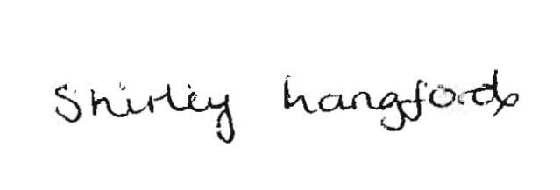

Shirley Langford

Chair of Governors