Leadership Scale L5 to L9 January 2022 (or sooner)
Do you have the vision, passion and determination to be a senior leader in our school, leading us into the next exciting stage of its development? If so, we would like to hear from you!
We are looking to appoint an Assistant Head Teacher who can bring leadership skills and an innovative approach to this role.
Alderman’s Green is part of Triumph Multi-Academy Trust since academizing on the 1st April 2021. You will be joining a Trust who believes in a collaborative and cooperative way of working. We believe in partnership and harnessing our collective talents to bring about the best opportunities and outcomes for our children.
Currently our school is on its journey of improvement for ages 3 to 11, we are looking ahead to the next stage in our development to ensure that the learning experiences are the best that they can be.
We are looking for a skilful leader who will: -

• Support the vision and values of the Trust and the school, to ensure the school’s improvement.
• Be child focused in their approach, putting children at the heart of everything they do.
• Have a successful track record of achieving improvement in a primary school setting.
• Be able to communicate their ideas clearly.
• Be a strategic thinker who can communicate their vision for the school clearly to all stakeholders.
• Have the ability to problem solve and to creatively resolve issues along the way.
• Be able to develop and build co-operative relationships within the whole school community.
• Be able to lead and inspire others and influence motivation, self- esteem, and teamwork.
• Have a positive approach to innovation and change and has the ability to make change happen.

Triumph Trust will offer:

• A leadership and coaching development programme;
• Happy, considerate and enthusiastic pupils who contribute fully to school life;
• A dedicated and hard-working team who are determined to provide our children with the best education;
• The opportunity to be part of an established and growing MAT;
• Leadership support and partnership across the schools within the trust, with a strong commitment to
mutual development.
• Excellent opportunities for continuous professional development through collaborative working and mentoring
Triumph Trust Board of Directors and the Local Governing Board warmly welcome your interest. Potential candidates are welcome to arrange a tour of the school and to discuss the post. Please contact Jenny Tegerdine at head@aldermansgreen.com or Sarah Malam the Executive Headteacher at malams@courthousegreen.org
Closing Date 2nd July (12pm) 2021 Interviews: 9th July 2021
Please return applications to recruitment@aldermansgreen.com. We are committed to safeguarding and promoting the welfare of all pupils and the successful applicant will be subject to enhanced clearance by the Disclosure and Barring Service and pre-employment check.

Dear Applicant
On behalf of the Governing Board I am delighted that you have shown an interest in the vacancy for Assistant Headteacher of Alderman’s Green Primary School. We hope that you consider making a formal application for the post.
We are an Ofsted rated ‘requires improvement’ school with a determination for improvement. We know we can do better.
We are looking for an inspirational Assistant Headteacher who will support the schools’ improvement journey, enabling staff to actively contribute to the positive outcomes for our children. We need an individual with the drive and passion who will ensure that all children achieve their full potential, combined with strong leadership, management and interpersonal skills. We have a positive, caring ethos and we are very proud of our school.
The school moved into the new building in 2011 which provides the children with a bright and spacious environment in which to learn. Starting as a three form entry it is now being reduced to a two form entry due to falling rolls. Our 12 place enhanced resource base is a high quality provision for children across the city with an EHCP for autism and offers an enhancement to our school.
We believe in the value of partnership and working with others in order to bring about school improvement; we were delighted to join Triumph Multi Academy Trust on the 1st April 2021 and believe this will support our journey of improvement.
We ensure that the necessary funds are available to enhance the quality of education that our children receive and have improved our technology offer; providing all pupils from Y2 upwards with their own iPad to support their learning.
Further information is available on the school website https://www.aldermansgreen.com
Thank you for considering this post. I look forward to hearing from you.
Yours sincerely
Hayley Shortt
Chair of Governors

Dear Applicant
Thank you for considering the submission of your application for the vacancy for the post of Assistant Headteacher at Alderman’s Green Primary School.
On 1st April 2021, Alderman’s Green became part of the Triumph Multi Academy Trust. Triumph is a small Trust, based in Coventry with a core purpose of putting learners first. The Trust’s growth is as a result of working in close partnership with the staff and governors of Alderman’s Green and Courthouse Green to ensure the very best educational opportunities can be provided for all children in both schools.
Following the involvement of Triumph Trust in September 2020 the progress against the school’s priorities has accelerated and through partnership with Courthouse Green and the appointment of a substantive Headteacher to the post, we expect it to continue to do so with a key focus on developing and improving teaching and learning.
We seek to appoint an Assistant Headteacher who will embrace our vision and values, will work closely with senior leaders and support the school on its journey of improvement to excellence and beyond, embracing our core purpose of ‘putting all learners first’. There are many opportunities across Triumph trust to work collaboratively in order to drive improvement.
Please find enclosed a range of information that will assist you in the preparation of your application, please make contact with us if you would like to discuss this post further.
We welcome your application.

Yours sincerely

Sarah Malam Carmen Hibbert
CEO Triumph Trust Chair of Triumph Trust

Alderman’s Green Primary School, Nursery and Resource Base is situated in the north-east of Coventry approximately four miles from Coventry City Centre.
The school has a fully inclusive ethos. We believe that every child at Alderman’s Green can achieve. By inspiring each other and encouraging positive relationships, children will thrive, using every moment so that they can all be the very best they can be. In November 2020 the Alderman’s Green staff team worked together to review the vision and values of the school to ensure that they reflected our ambition for our children and our drive to ensure that the climate and ethos promoted the very highest expectations.
Our vision statement reflects this:
Alderman’s Green where everyone believes in us and we believe in ourselves
We seek to ensure that children leave school with a secure love of learning, curiosity that will inspire success and independence for the future.
Our Core Values of Resilience, Responsibility, Pride, Kindness and Collaboration support us in ensuring that our school is a happy, safe place to learn where children grow both personally and academically.

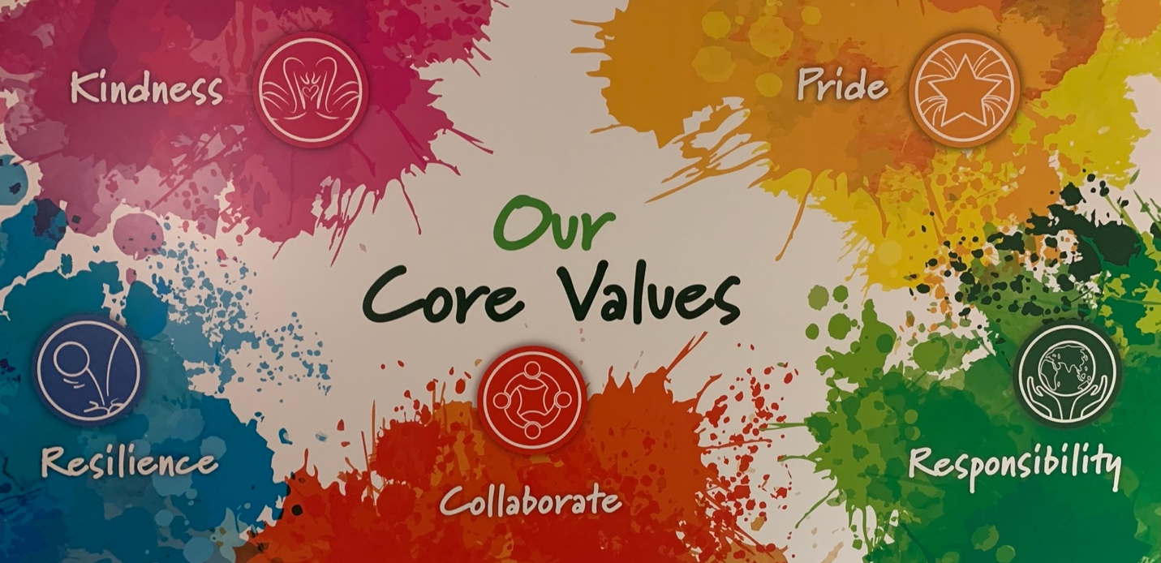

Alderman’s Green Primary School is a larger than average primary school. It is a three-form entry school (reducing to a two form entry), with a 26 place Nursery, with currently 520 pupils on roll.
The school serves a diverse and disadvantaged area and pupils start Foundation Stage with attainment below national expectations; over 35 community languages are spoken, with over a quarter of pupils speaking English as an additional language. While many families face many social, economic and financial challenges (36% receive FSM), our school motto ‘Where everyone believes in us and we believe in ourselves’ reflects our belief that all of our children can, and will, succeed. The Leadership Team consists of Head Teacher and 2 Deputy Head Teachers. The extended leadership of the school includes 2 Assistant Head Teachers. This experienced, largely non-class based leadership team supports staff and children, with a clear drive on raising standards.
Although currently judged as a school requiring improvement, the staff team and Governors are focused on improving the quality of education for all pupils through working together to raise standards and expectations as a whole school team.
We believe that every child at Alderman’s Green can achieve. By inspiring each other and encouraging positive relationships, children, will thrive, using every moment so that they can all be the very best they can be. We are very proud to be a school that has embraced the Thrive approach which gives us the tools to develop healthy, happy confident children who are ready to learn and cope with challenges in their learning and lives. Thrive is based on the latest advances in neuroscience, attachment theory and child development with a strong focus on helping children identify and express their emotions in a healthy way.

We have nurtured a broad and balanced curriculum based around the Cornerstones Curriculum which is a creative and thematic approach to learning, providing and inspiring a wide range of outstanding learning opportunities for all children to learn and excel. We believe teaching and learning should be exciting and engaging. The curriculum is built on a wide variety of curriculum related experiences through trips and visits and children are encouraged to learn actively.

Through improving teaching and learning across school we will raise attainment across the curriculum. We believe that our children still have incredible potential to reach further, especially in higher standards and greater depth. Current school self-evaluation grades the school as requires improvement.
Our school Improvement Plan has three key priorities:
- To ensure consistency in the quality of teaching and learning so that all pupils, especially disadvantaged and most able, make good progress.

- Ensure that all leaders are effective in their specific roles to enable others to increase % of pupils working at Age Expected standards in July 2021, diminishing the difference with national in Reading, Writing and Maths at EYFS, KS1 and KS2.

- To ensure that our core values underpin all aspects of school practice, promoting a climate of care, support and ambition enabling children to achieve their very best.

Start date: January 2022 or earlier

If you believe you have the skills and attributes to successfully take on this exciting new role and make a real difference to the outcomes for our children, then we warmly welcome your application.

Application is:
- Completed application form which includes 2 sides of A4 demonstrating your leadership skills and professional qualities and impact, to date.
- Statement outlining, in your opinion, the greatest challenge facing education in the next 3 years (500 words).
Applications should be sent to recruitment@aldermansgreen.com by 12:00pm on 2nd July 2021.
Interview date: Friday 9th July 2021.
For an informal conversation or to book a tour of the school please email Jenny Tegerdine (Headteacher) at head@aldermansgreen.com or call the school office on 024 76688918.

Referees will be asked to provide a reference for all short listed candidates. Preferred referees are your last two employers, likely to be your last Headteacher or Chair of Governors.

Triumph Trust is committed to safeguarding and promoting the welfare of children and young people/vulnerable adults and expects all staff and volunteers to share this commitment. This position is subject to a criminal records check from the Disclosure and Barring Service (formerly CRB) which will require you to disclose details of all unspent and unfiltered spent reprimands, formal warnings, cautions and convictions in your application form. Relevant pre-employment checks may also include considering information shared within the public domain.

