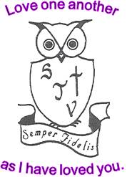
Welcome to St John Vianney where Christ is at the centre of everything we do.

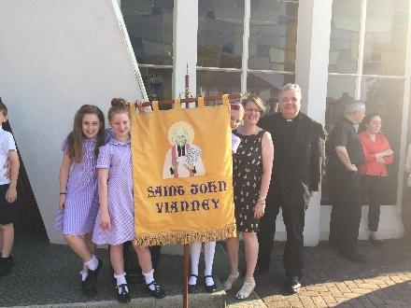
We have one school rule which is to Love one another as I have loved you. We strive to promote the values of our Christian faith throughout our daily life. We provide a religious syllabus, which develops our children's knowledge and understanding of our faith. However, more important to this school are those values, which we try to relate to all the aspects of our life within the faith community of St John Vianney's Parish.
St John Vianney's is a happy and caring school where every child is known and loved. We seek to challenge and support all our children and make them excellent citizens of the future, knowing how important it is to do their best and care for those around them. We are conscious of the necessity to provide our pupils with a broad and balanced curriculum and constantly review and evaluate the achievements of the school. We aim to provide both high academic standards and a good faith basis.
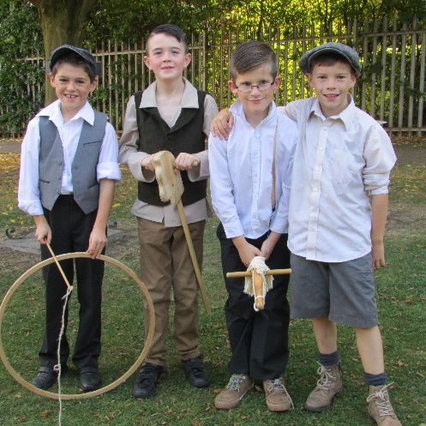
St John Vianney's strives to achieve its aims through a strong partnership between governors, staff, children, parents and Parish. Most of our governors are parents or past parents and members of our Church community. We believe that this improves the level of co-operation and the sense of shared commitment and responsibility.
We believe that we can only achieve the best for your child by close co-operation between home and school.
For more information or to arrange a visit, please do not hesitate to contact me at the school.
Yours sincerely Veronica Gosling

