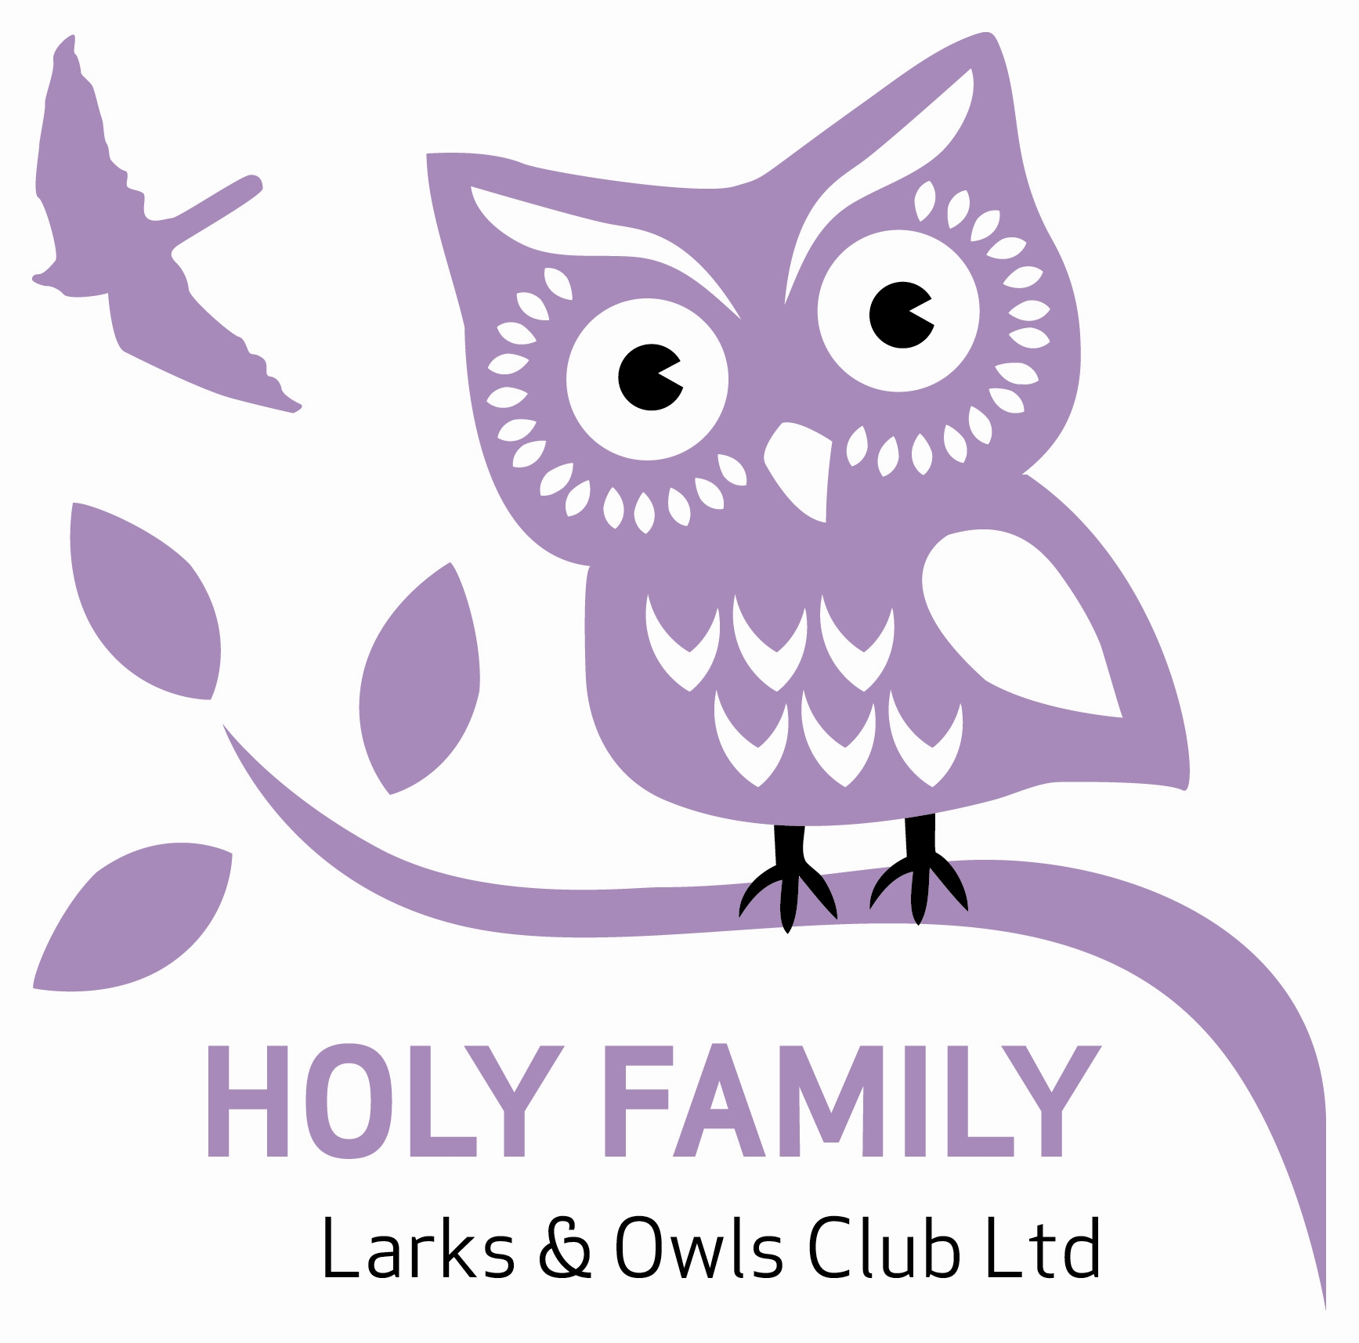
Holy Family Larks & Owls Club Ltd
c/o Holy Family Catholic Primary School, Penny Park Lane, Coventry. CV6 2GU.
Tel: 07800 634991
Email address: LandO@holyfamily.coventry.sch.uk

Job Application Form

Post applied for Club Manager

Personal details (please write in block capitals)
Full name:
Former names:
Address:  Postcode: | Daytime contact number:  Home telephone number:  Email:  Date of birth:
National insurance number:
Notice period, or date when you would be available to start work:

Employment history
A full history in chronological order since leaving Secondary Education must be provided (no gaps). Please give details of your current or most recent employment first. Include all paid and voluntary work.
Start / end date | Employer name and address | Job title | Nature of work
Continue on a separate sheet if necessary.
Education, training and development
Please give details of your education and training, starting with the most recent. Include any formal qualifications – especially those relevant to this post (proof of qualifications will be required at interview)
Start / end date | University, college, school or training establishment | Qualification or course details (specify awarding body and date of award) | Grade

Personal statement
Please state why you think you are suitable for this job. Give examples where appropriate and ensure that you address the points covered in the job description and person spec. Continue on an additional sheet if necessary.
References
Please give the contact details of two people who are willing to provide references regarding your suitability for the post. One must be your current or most recent employer. References will not be accepted from family or friends.

First referee: Present / most recent employer | Second referee
Name:  Address:  Email:  Telephone:  Relationship to applicant: | Name:  Address:  Email:  Telephone:  Relationship to applicant:

Can we approach your referees prior to interview? Yes / No (please note we will require references prior to interview)

Are you related to or do you have a close relationship to existing employees or employers?
……………………………………………………………………………………………………………….

Criminal convictions
Due to the nature of this post and the law relating to it, you must disclose all criminal convictions and cautions. It is a condition of any subsequent employment that you have done so. Failure to disclose a conviction or caution could result in dismissal or disciplinary action. This post is exempt from the Rehabilitation of Offenders Act 1974 and therefore all convictions, cautions and bind-overs, including those regarded as spent must be declared.

Any information that you supply will be dealt with on a confidential basis. Holy Family Larks & Owls Club will only take into account when considering your application those convictions or cautions relevant to the nature and purpose of the post for which you are applying.

The post is subject to a satisfactory Enhanced Criminal Records Bureau Disclosure being obtained for the successful applicant.

Declaration
I have read and understood the above statement. If I have any convictions or cautions to declare I will supply details of them at the time of application to Holy Family Larks & Owls Club Ltd at the address shown below:

I further certify that the information contained on this application form is accurate and true.
I am not disqualified from working with children. I understand that my current employer will be asked to confirm any disciplinary offences relating to children including any which are time expired.

Signed: …………..…………………………………………………………………… Date: …………...……

Please return this form to Holy Family Larks & Owls Club Ltd by Friday 28th August 2020 to LandO@holyfamily.coventry.sch.uk

Holy Family Larks & Owls Club Ltd” is committed to safeguarding and promoting the welfare of children and expects all staff and volunteers to share this commitment”.

