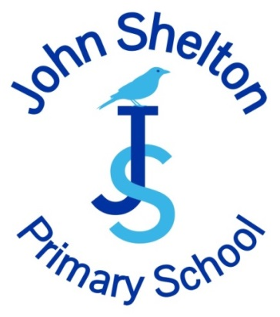 | Job Description

Job Title: | Cleaner | Job Number:
Directorate: | People Directorate | Post Number:
Service: | Cleaning | Grade: | Grade 1
Location: | John Shelton Primary School Term Time Only

Job Purpose:

Undertake, normally as part of a team, the cleaning of designated areas within John Shelton Primary School, to ensure that they are kept in a clean and hygienic condition.

Main Duties and Responsibilities:

1. Cleaning, washing, mopping, sweeping, buffing, vacuum cleaning of all designated areas.

2. Cleaning of toilets and emptying rubbish bins.

3. Polishing and dusting of the designated areas, (may include toilets and shower areas).

4. Internal glass panels ,fixtures and fittings, using where appropriate powered equipment and cleaning materials according to the agreed procedures.

5. Moving furniture and equipment to assist cleaning.

- Open and lock doors as required, collecting and returning keys to caretaker or other supervisor.
Setting alarms where required.

7. Makes sure that work is carried out to the standard required.

8. Any other duties and responsibilities within the range of the salary grade.

All employees

The post holder must comply with John Shelton Primary School health and safety policy and in particular is required:-
- To take reasonable care for their own health and safety at work and of those who may be affected by their actions or by their omissions
- To cooperate with their line manager and senior management, to work safely, to comply with health and safety instructions and information and undertake appropriate health and safety training as required
- Not to intentionally or recklessly interfere with or misuse anything provided in the interests of health, safety and welfare
- To report to their manager any health and safety concerns, hazardous condition or defect in the health and safety arrangements.

Responsible for:

Responsible to: Site Service Officer /School Business Manager

Date Reviewed: March 2024

Updated: March 2024

 |  | Person Specification
Job Title: | Cleaner |  | Job Number:
Directorate: | People |  | Post Number:
Service: |  |  | Grade: | Grade 1
Location: | John Shelton Primary School

Area | Description
Knowledge: | - Basic health and safety principles
Skills and Abilities: | - Able to clean to a required standard.
 | - Able to understand and respond to verbal instructions.
 | - Ability to read and write for the purposes of understanding warning notices etc. on cleaning chemicals and general information and completing basic forms such as timesheets, etc.
 | - Able to lift and move heavy cleaning equipment and furniture, e.g. floor polishers; vacuum cleaners, etc.
 | - Able to stand; bend and stretch to undertake cleaning duties such as cleaning; sweeping and vacuuming for the duration of the shift.
 | - Able to work unsupervised.
 | - Able to work as a team.
 | - Ability and willing to undertake training on basic health and safety in the cleaning environment.
 | - Able to adhere to the school's Equal Opportunities Policy.

Experience:

Educational:

Special Requirements: | - This post is exempt from the provisions of the Rehabilitation of Offenders Act 1974. A Criminal Record Disclosure will be required prior to appointment.

Date Reviewed: March 2024

Updated: March 2024

