Dear applicant

Thank you for your interest in the post of Teaching Assistant. Completed applications should be returned to angela.grenfell@st-annes.coventry.sch.uk The closing date for applications is Thursday 25th November 2021 at 6 p.m.

We are now in a position to be able to warmly welcome visits to our school ahead of the interview date and would like the opportunity to show you that we are a happy, welcoming school that has a lot to offer to the successful candiate.

If you would like to arrange a visit or have any questions please do not hesitate to contact the school on 02476 302882.

We look forward to hearing from you.

Yours sincerely
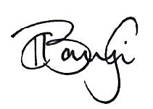

Mrs Keri Baylis
Headteacher

