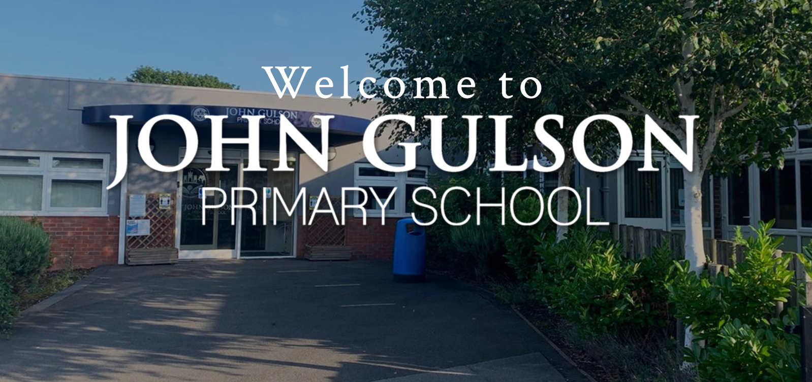



Cleaner
February 2023

CANDIDATE PACK

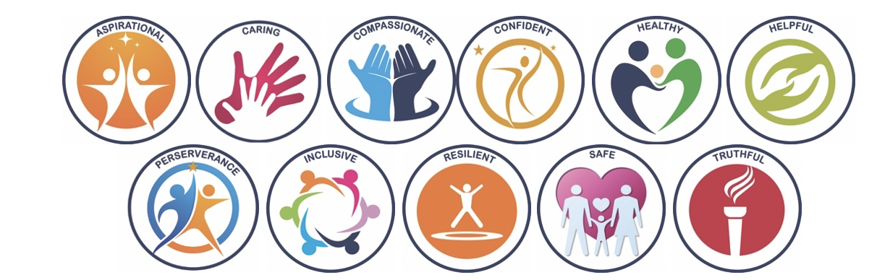

Contents Page

- Welcome from the Headteacher………………………………………….

- Welcome from the Head of Teaching, Learning ad Curriculum and the Head of Safeguarding, SEND, Behaviour and Pastoral Care………………….

- Mission, Vision and Values ………………………………………………

- School Context ……………………………………………….……………

- Governance ……………………………………………………………….

- Staff Structure …………………………………………………………….

- School Improvement Targets 2022-2023 ………………………………

- Equality and Inclusion ……………………………………………………

- Cleaner Advert……………………………………………

- Cleaner Job Description …………………………………

- Cleaner Person Specification …………………………..

- Staff Wellbeing ……………………………………………………………

- Professional Development ………………………………………………

WELCOME FROM THE HEADTEACHER



Thankyou for taking an interest in the post of Cleaner at John Gulson Primary School. I hope this candidate pack will give you information and insight into our school and the community we serve.
My name is Ms. Sumner and I am very proud to be Headteacher of such a richly diverse school community in which different languages, cultures and religions learn together and from each other.
Our mission is to ensure that all members of the school community has passionate ambition and commitment to learning; we recognise the uniqueness of every individual in the pursuit of excellence. Our mission is driven by our desire to offer the best education for our pupils in partnership with parents, carers, Governors and the wider community. We believe our approach will inspire a love of learning and unlock the talents that lie within all of our children, preparing them to be kind, happy, successful and responsible citizens of the future.
We are a friendly, caring school with high expectations for all our pupils and a strong commitment to the mental health and wellbeing of all within our community. Our children are encouraged to explore, discover and question through a range of exciting learning opportunities both within and outside the classroom. The staff endeavour to provide a calm and stimulating environment where good behaviour and mutual respect is modelled by everyone and where everyone is valued.

Ms. V Sumner

Welcome from the Head of Teaching, Learning and Curriculum and the Head of Safeguarding, SEND, Behaviour and Pastoral Care
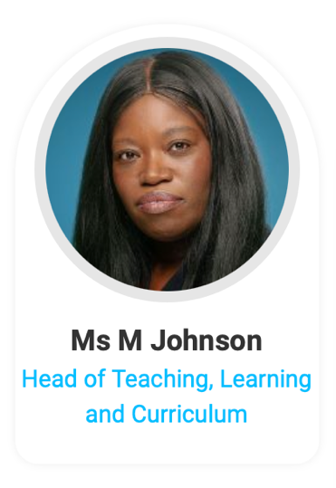
At John Gulson we pride ourselves on our demonstrating our values through our conduct, through our curriculum and how we support each other. We want to create an environment where our children receive the best education in a nurturing environment. My role in school is to help develop staff to be the best that they can be in providing a high-quality provision to our pupils. I also support subject leaders in developing an exciting, tailored curriculum and improving their own skills as leaders.

Working at John Gulson will mean that you will receive excellent CPD and the opportunity to further your own career with access to bespoke training. You will also be able to work collaboratively with your own and the wider team. We are a supportive workplace that values you as an individual and are also committed to ensuring that wellness for all is a priority.

We are in an exciting period of transition of creating a school that we are all proud to be a part of and you have the chance to be a part of that journey.

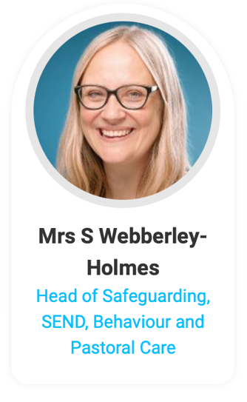
My name is Suzanne Webberley Holmes and my role in school is Head of Safeguarding, SEND, Behaviour and Pastoral Care. I have worked in the school for a number of years in different roles and took up this new post in April 2021. I am a qualified SENDCO and am currently undertaking my NPQH qualification. My role centres around supporting children and families, in particular those with additional vulnerabilities, to access high quality provision which meets their needs and also ensure any additional needs are met. Safeguarding is of the highest importance at our school and is at the heart of all we do in school and is central to all of my role. Part of my role is to lead on behaviour and we work hard at school to ensure our approach is built around relationships and good choices. I lead a team of pastoral staff and oversee our nurture provision and EAL provision. The children and families and staff at John Gulson are a joy to work alongside.



MISSION STATEMENT
John Gulson Primary School reflects passionate ambition and commitment to learning and we recognise the uniqueness of every individual in the pursuit of excellence.

VISION
Our mission is driven by our desire to offer the best education for our pupils in partnership with parents, carers, Governors and the wider community. We believe our approach will inspire a love of learning and unlock the talents that lie within all of our children, preparing them to be kind, happy, successful and responsible citizens of the future.

VALUES

SCHOOL CONTEXT
John Gulson Primary School is a larger than average primary (2 forms of entry in Years R-5 and 3 forms of entry in Year 6. We have a 36-place morning Nursery provision. We are based within an area of high deprivation in central Coventry (Foleshill). The school ranks amongst the top 20% in terms of deprivation (idaci 0.36). There are high levels of mobility within the school. At our recent OFSTED inspection (March 2022), we were praised for the progress we had made towards significant school improvement. Despite being graded by the LA in early 2020, we got ‘Good’ in all areas with the exception of Quality of Education; this was identified as RI but with targets being to keep doing what we are doing!
Currently, numbers in each year group as follows:

Nursery: 30
Reception: 60
Year 1: 60
Year 2: 60
Year 3: 60
Year 4: 59
Year 5: 57
Year 6: 85
35% of pupils are disadvantaged (compared to 20.8% nationally).
75% of pupils have English as an additional language (compared to 19.3% nationally).
14.71% of pupils have SEND - 0.85% EHCP and 13.86% SEND support (compared to EHC 3.7% and SEND Support 12.25% nationally).
The ethnic backgrounds of our pupils are:
- Bangladeshi 11.7%
- Black African 9.6%
- Black Caribbean 0.4%
- Gypsy Roma 2.8%
- Indian 11.7%
- White and Asian 2.1%
- Pakistani 23.7%
- Wite British 6.0%
- White and Black Caribbean 0.9%
- Roma 0.2%
- White and Black African 0.2%
- Other Asian 16.2%
- Other Black 0.2%
- Other Ethnic 3.8%
- Other Mixed 2.3%
- Other White 5.8%
Attendance figures for the 2021-2022 were 93.9%; punctuality is improving and processes to tackle absenteeism and poor punctuality are robust.

GOVERNANCE
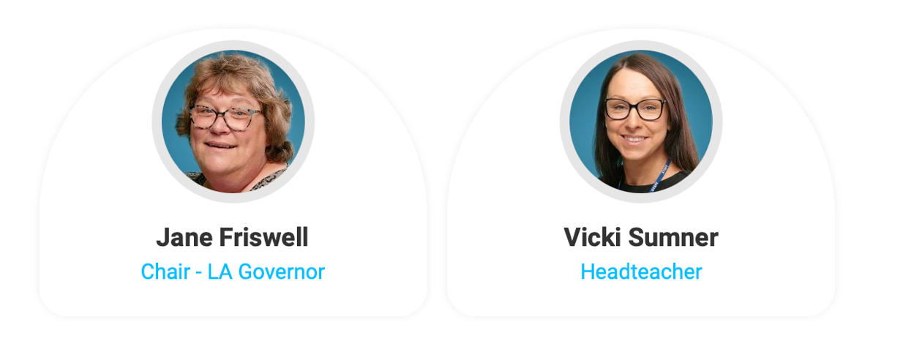



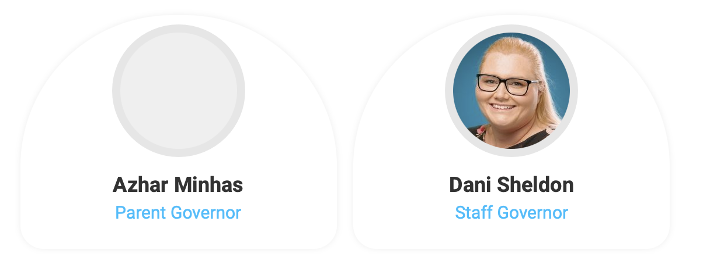

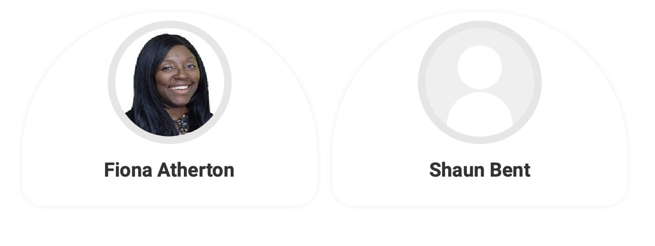

STAFF STRUCTURE 2022-2023

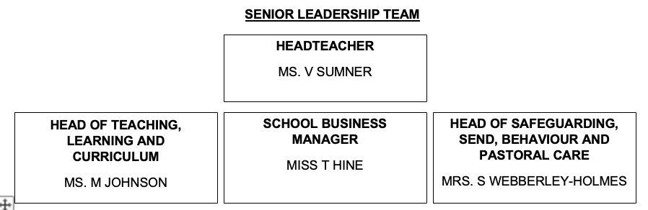
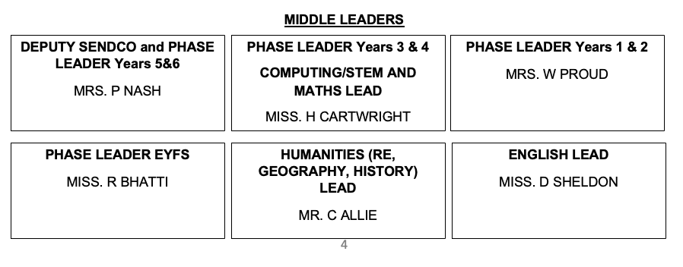

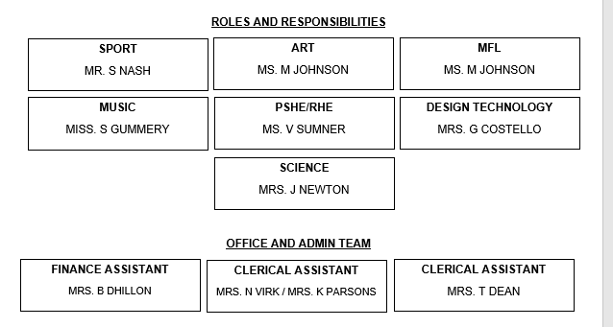
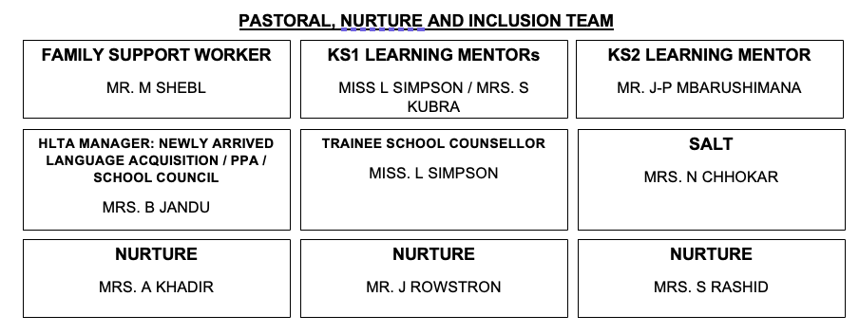

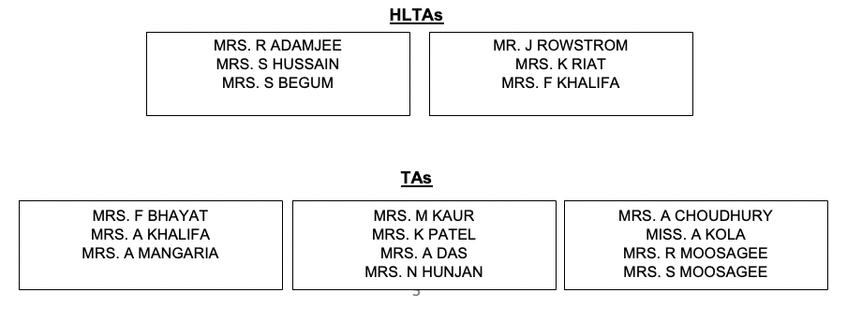

SCHOOL IMPROVEMENT TARGETS 2022-2023

Key Priority 1: QUALITY OF EDUCATION OBJECTIVES 2022-2023

- All children will receive a good or better education.
- All children receive a full and ambitious curriculum that is planned and designed to meet the needs of all learners within our community.
- Develop and embed an effective whole school approach to oracy
Key Priority 2: BEHAVIOUR AND ATTITUDES OBJECTIVES 2022-2023

- Pupils behave with consistently high levels of respect for others. They play a highly positive role in creating a school environment in which commonalities are identified and celebrated, difference is valued and nurtured, and bullying, harassment and violence are never tolerated.
- Pupils consistently have highly positive attitudes and commitment to their education. They are highly motivated and persistent in the face of difficulties. Pupils make a highly positive, tangible contribution to the life of the school and/or the wider community. Pupils actively support the well-being of other pupils
- Pupils behave consistently well, demonstrating high levels of self-control and consistently positive attitudes to their education. If pupils struggle with this, the school takes intelligent, fair and highly effective action to support them to succeed in their education

Key Priority 3: PERSONAL DEVELOPMENT OBJECTIVES 2022-2023
- The school consistently promotes the extensive personal development of pupils. The school goes beyond the expected, so that pupils have access to a wide, rich set of experiences. Opportunities for pupils to develop their talents and interests are of exceptional quality.
- There is strong take-up by pupils of the opportunities provided by the school. The most disadvantaged pupils consistently benefit from this excellent work.
- The school provides these rich experiences in a coherently planned way, in the curriculum and through extra-curricular activities, and they considerably strengthen the school’s offer
- The way the school goes about developing pupils’ character is exemplary and is worthy of being shared with others
Key Priority 4: LEADERSHIP AND MANAGEMENT OBJECTIVES 2022-2023

- Middle leaders have full knowledge, understanding and accountability of/for their subject area. As a result, standards for all children are high and outcomes for all children improve.
- Senior and middle leaders provide high quality CPD for all staff (inc. ECTs), leading to consistently good or better teaching and learning. Outcomes for all children improve as a result.
- Governors make termly visits to school to review their area of responsibility (linked to the SIP). As a result, Governors have a detailed knowledge and understanding of school priorities and progress towards these.
Key Priority 5: EYFS OBJECTIVES 2022-2023

- To improve the Quality of Education in Early Years Foundation Stage to Outstanding.
- To improve EYFS outcomes from 65% to above national average (2022).

EQUALITY AND INCLUSION

EQUALITY STATEMENT
All pupils and members of staff at John Gulson Primary School Primary School are provided with opportunities to fulfil their potential without discrimination of any kind, as referenced in the protected characteristics of the Equality Act 2010.

Our school aims to meet its obligations under the public sector equality duty by having due regard to the need to:
- Eliminate discrimination and other conduct that is prohibited by the Equality Act 2010
- Advance equality of opportunity between people who share a protected characteristic and people who do not share it
- Foster good relations across all characteristics – between people who share a protected characteristic and people who do not share it
The above applies to adults and children alike.

At John Gulson Primary School, we two assemblies per week are based upon teaching about the protected characteristics; this is done via the sharing of high-quality, age-appropriate texts.

Our school improvement plan identifies how we will ensure that we have an explicit focus upon equality for each of our objectives.

INCLUSION

We are committed to using our best endeavours to provide an appropriate and high-quality education for all children at our school which enables them to

- Achieve their best
- Become confident individuals living fulfilling lives
- Make successful transition to their next phase of education.

We consider every teacher to be a teacher of every child, including those with special educational needs and disabilities.

We have the highest aspirations and expectations for all pupils, including those with special educational needs.

We aim to achieve a community where parents and those working in school have a mutual trust and confidence in each other, created through clear, consistent approaches to communication and collaborative working, to enable outstanding outcomes for all children, including those with SEND.

We aim to provide all children, including those with special educational needs and disabilities, with a broad, balanced academic and social curriculum, which is accessible and ensures they are fully included in all aspects of school life and feel equally valued and contribute fully to the school community.

To achieve this we will:

1. Strive to establish a fully inclusive school, eliminate all prejudice and discrimination and create an environment where all children can be happy, progress and feel safe.

2. We will respond to learners in ways which take account of their varied needs and life experiences, moving away from an approach that locates a problem within the child, but means doing everything we can to meet a child’s SEN.

3. We are committed to identifying a pupil’s special educational needs at the earliest point and then making effective provision as this is known to improve long term outcomes.

4. Working in close partnership with parents to achieve these aims, we are committed to parents participating as fully as possible in decision making and being provided with information and support necessary to enable this.
5. Support pupils themselves to participate in discussions and express their views and be fully involved in decisions which affect them encouraging them to become increasingly effective self-advocates.
6. Work in close partnership with a range of specialist agencies to enable us to provide effective targeted support.
7. Provide support, advice and training for all staff working with pupils with special educational needs to enable them to be increasingly able to adapt teaching to respond to the strengths and needs of all pupils.

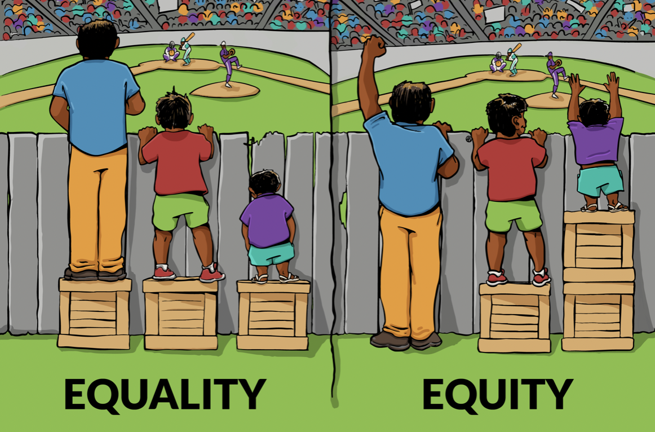

School Name: | JOHN GULSON PRIMARY SCHOOL
Full Address: | GEORGE STREET  COVENTRY  CV1 4HB
Telephone Number: | 024 7622 7791
Email Address:  (for application forms) | t.hine@johngulson.coventry.sch.uk
Job Title: | 1 Post for a cleaner
Is the post temporary and length of Contract | Permanent Contract
Hours: | 10
Please insert if TTO | Term time only (38 weeks)
Salary range: | Grade 1 (£10.50 – £10.59 per hour)
Advert text: | John Gulson Primary School  George Street  Coventry  CV1 4HB    The School Business Manager and Site Service Manager are looking to appoint an enthusiastic, highly motivated, and flexible Cleaner to work in our friendly and caring inner city, multicultural primary school.  We are looking for someone who will ensure that high standards of cleanliness are maintained within our school. You will be required to undertake general cleaning duties to ensure the school is kept in a clean and hygienic condition. You will be required to use a range of equipment, as required, in specified areas within the school in accordance with the school’s standards. You should be able to work individually and as part of a team.  The vacancy is for 12.5 hours a week over 5 days, 3:15-5:45pm, term time only.  This post is exempted under the Rehabilitation of Offenders Act 1974 and as such appointment to this post will be conditional upon the receipt of a satisfactory response to a check of police records via Disclosure Barring Service.  This School is committed to safeguarding and promoting the welfare of children and expects all staff to share this commitment.
Closing date: | Monday 6th February 2023
Interview date: | TBC
Do you require the following sentence: Yes | For an informal visit please contact the school by e-mail to t.hine@johngulson.coventry.sch.uk
Application option - Please delete as applicable* | Applications packs are available to download from www.wmjobs.co.uk and are returnable direct to the school t.hine@johngulson.coventry.sch.uk (if you choose this option, please include your job description, person spec and application form when you return this form)


Cleaner

Job Description

Job Purpose:

Undertake, normally as part of a team, the cleaning of designated areas within school to ensure that they are kept in a clean and hygienic condition.

Main Duties and Responsibilities:

1. Cleaning, washing, mopping, sweeping, buffing, vacuum cleaning of all designated areas.

2. Cleaning of toilets and emptying rubbish bins.

3. Polishing and dusting of the designated areas, (may include toilets and shower areas).

4. Internal glass panels, fixtures and fittings, using where appropriate powered equipment and cleaning materials according to the agreed procedures.

5. Moving furniture and equipment to assist cleaning.

6. Open and lock doors as required, collecting and returning keys to Site Service Officer or other supervisor. Setting alarms where required.

7. Makes sure that work is carried out to the standard required.

8. Act in accordance with City Councils practice that clients are treated courteously.

9. Any other duties and responsibilities within the range of the salary grade.

The post holder must comply with Coventry City Council’s health and safety policy and in particular is required:-

• To take reasonable care for their own health and safety at work and of those who may be affected by their actions or by their omissions
• To cooperate with their line manager and senior management, to work safely, to comply with health and safety instructions and information and undertake appropriate health and safety training as required
• Not to intentionally or recklessly interfere with or misuse anything provided in the interests of health, safety and welfare
• To report to their manager any health and safety concerns, hazardous condition or defect in the health and safety arrangements.

Any further Health and Safety responsibilities relevant to this post will be set out in the offer letter and Written Statement of Particulars

The post holder must comply with the Interagency procedures of the Safeguarding Boards and Coventry City Council’s policies for safeguarding children and safeguarding adults and in particular is required:-

• To ensure they are aware of the signs that may suggest a child or vulnerable adult is being abused or neglected
• To report to their manager, or other appropriate manager, any concerns they may have that suggest that a child or vulnerable adult may be being abused or neglected immediately

Any further Safeguarding Board responsibilities relevant to this post will be set out in the offer letter and Written Statement of Particulars

Post holders will be accountable for carrying out all duties and responsibilities with due regard to the City Council's Equal Opportunities Policy.

Duties which include processing of any personal data must be undertaken within the corporate data protection guidelines.

Responsible for:

Responsible to: Headteacher (or designated Line Manager)

Date Reviewed: June 2017

Cleaner

Person Specification

Area |  | Description
Knowledge: |  | Basic health and safety principles
Knowledge: | • | Cleaning techniques and equipment

Skills and Abilities: | • | Able to clean to a required standard.
Skills and Abilities: | • | Able to understand and respond to verbal instructions.
 | • | Ability to read and write for the purposes of understanding warning notices etc. on cleaning chemicals and general information and completing basic forms such as timesheets, etc.
 | • | Able to lift and move heavy cleaning equipment and furniture, e.g. floor polishers; vacuum cleaners, etc.
 | • | Able to stand; bend and stretch to undertake cleaning duties such as cleaning; sweeping and vacuuming for the duration of the shift.
 | • | Able to work unsupervised.
 | • | Able to work as a team
 | • | Ability and willing to undertake training on basic health and safety in the cleaning environment.
 | • | Able to adhere to the City Council's Equal Opportunities Policy.

Experience: | • | Cleaning techniques and equipment
Educational: | •

Special  Requirements: | • | This post is exempted under the Rehabilitation of Offenders Act 1974 and as such appointment to this post will be conditional upon the receipt of a satisfactory response to a check of police records via Disclosure and Barring Service (DBS).

Date Reviewed: June 2017

STAFF WELL-BEING

At John Gulson Primary School, staff well-being is central to who we are and what we do. Staff well-being comes in various guises; we are robust in ensuring that our approach to well-being is not tokenistic but rather has demonstrable impact of the working lives of all staff within our care.

We have 3 policies bespoke to staff well-being:

- Staff Well-Being Policy;
- Menopause Policy;
- Staff Domestic Abuse Policy.

On a practical, day-to-day basis you can expect:

- Joint PPA with your year group colleague in a half-day block to encourage collaborative thinking and support. This can be taken on- OR off-site;
- A commitment to reducing unnecessary workload;
- One INSET day per year dedicated to well-being;
- One staff meeting per term dedicated to staff well-being;
- Access to counselling via the Promoting Health at Work process;
- A supportive SLT with an open door policy;
- Access to fitness class once per week;
- Ongoing commitment to professional development, ranging from developing classroom practice to developing yourself via higher education or completion of a NPQ;
- A real commitment to work-life balance.
- We have 7 adult mental health first aiders, consisting of a variety of staff within a variety of roles to provide expert support where required.

PROFESSIONAL DEVELOPMENT

Access to consistent, quality professional development is essential within a school system that is constantly changing and developing.

We place CPD as a key priority for all staff members in all roles:

- Weekly staff meetings based around coaching and mentoring;
- Annual CPD meetings with the Headteacher to plan out a 1-, 3- and 5-year professional development journey;
- Access to ongoing training bespoke to your role in school;
- Access to networking via our involvement with the Compass network within Coventry;
- A developing peer support system;
- Access to a range of qualification opportunities including NPQs and higher education opportunities.

We want to invest in our staff and their professional development; not only is it our job as a school to ensure we have the highest calibre of expertise, but it is our job to develop the next generation of school leadership. This is a job we take extremely seriously. Within the EYFS Lead role, you would also have bespoke support from EYFS consultants and a Phonics consultant.

