Section A
If you have a disability and you require this form in another format, please contact our HR Department at hr@covmat.org

Post Applied For:
Academy:
Where did you hear about this vacancy?
MAT/Academy website  TES  LinkedIn | ☐  ☐  ☐ | Teach First  eteach  WMJobs |  | ☐  ☐  ☐ | Future Leaders  Word of mouth  Other | ☐  ☐  ☐
If you heard about this vacancy through a member of the MAT please provide their name so we can thank them.

Personal Details
Surname (including preferred title)
First Name(s) |  | Known as
Address and postcode
Home Telephone No:
Work Telephone No:
Mobile Telephone No:
E-Mail Address
National Insurance Number |  | Date of Birth
Previous Surnames Used
Are you eligible to work in the UK? | YES ☐ NO ☐
Do you require a work permit or visa? | YES ☐ NO ☐
If yes, please give details
Please state what documentation you can provide to demonstrate this e.g. British Passport, EEA ID card, passport or travel document showing an authorisation to reside and work in the UK
Note: You will be asked to bring this documentation with you to the interview.
An offer of employment will be subject to successful verification of your right to work in the UK.

Sections A, B and E of the Application Form will be detached prior to being forwarded to the short-listing panel members. All sections of the form will be shared with the panel after short-listing has been completed.
Application Form
Section B

Data Protection Statement
The information that you provide on this form and that is obtained from other relevant sources will be used to process your application for employment. The personal information that you share may be used in a confidential manner to help us monitor our recruitment process.

On making an application to and/or becoming employed with us, the information will be used in compliance with GDPR and our Privacy Notices which can be found on the Information & Resources page of our website www.covmat.org.

We may check the information collected, with third parties or with any other information held by us. We may also use or pass to third parties, information to prevent or detect crime, to protect public funds, or in other ways as permitted by law.

By signing this application form you are providing your consent for us to process your personal data, in accordance with our registration with the Information Commissioner’s Office.

Declaration
I acknowledge that the Multi Academy Trust (MAT) is committed to safeguarding and promoting the welfare of children and young people and to this end hereby confirm that I am not on the barred list or List 99, disqualified from work with children, or subject to sanctions imposed by a regulatory body such as the Teacher Regulation Agency, and have no convictions, cautions or bind-overs (or have attached details of my record in a sealed envelope marked confidential).

I agree to a DBS check if appointed to the position for which I have applied. I am aware that details of pending prosecutions, previous convictions, cautions, or bindovers against me will be disclosed along with any other relevant information which may be known to the police, and Lists held in accordance with the Safeguarding Vulnerable Groups Act 2006.

I agree to inform the MAT if I am convicted of an offence after I take up any post within the MAT. I understand that failure to do so may lead to the immediate suspension of my work with children and/or the termination of my employment.

I agree to inform the MAT if I become the subject of a police and/or a social services (Children’s Social care or Adult Social Services) / social work department investigation. I understand that failure to do so may lead to the immediate suspension of my work with children and/or the termination of my employment.

I agree to provide the Academy with a ‘Certificate of Good Character’ if I have been out of the United Kingdom during the last 10 years for 3 consecutive months or more. ‘Certificates of Good Character’ can be obtained from the Embassy of the country you have visited/lived in. The application process for ‘Certificates of Good Character’ for someone from overseas varies from country to country. Please read the guidance document here. If you have any questions regarding applying for a ‘Certificate of Good Character’, then please contact hr@covmat.org

We need to draw your attention to the requirements of the Childcare Act 2006 and the Childcare (Disqualification) Regulations 2009 and the related DfE Statutory Guidance. It is a criminal offence for a Trust or Academy to employ a person to work in connection with early provision who is disqualified from doing so under the Regulations. For roles that involve providing care for pupils under 8. I declare that I have not been subject to disqualification against children.

In accordance with paragraph 221 Keeping Children Safe in Education, schools should carry out online searches to identify any incidents or issues that have happened and are publicly available online. Checks will not be carried out by the appointing officer. Only relevant information relating to safeguarding or reputational concerns will be highlighted to the appointing officer. Any matters of interest will be considered with you to establish your suitability for the role for which you have applied.
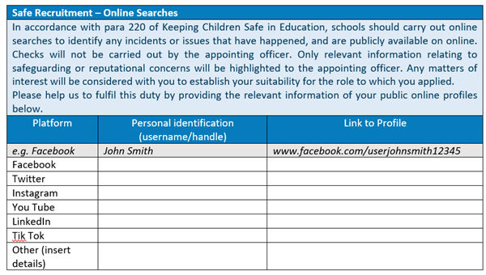
I declare to the best of my knowledge and belief, all particulars I have given in all parts of this application form are complete and true and can be treated as part of any subsequent contract of employment. I understand that any false declaration or misleading statement or a significant omission may disqualify me from employment and render me liable to dismissal. I understand that any job offer is subject to references, checks on relevant qualifications, employment eligibility and criminal convictions, and a medical report, all of which must be deemed by the MAT as satisfactory.

Signed |  | Date

Application Form
Section C

If you are applying for a teaching post, please provide the following information:
Do you have QTS? | YES ☐ NO ☐
In what year did you gain QTS?
Please provide your Teacher Reference Number (DfE)
If you qualified after September 1999, have you completed your NQT statutory induction year? | YES ☐ NO ☐
Note: The MAT will require proof of essential qualifications detailed in the Person Specification at interview, this includes evidence of QTS and completion of Induction if applicable.

Continuous Service
The MAT may recognise continuous service in Local Government Employment for all staff groups in order to calculate entitlements for redundancy.
What is your continuous service in LGE? | (DD/MM/YY)

Note: If you are offered the position, your continuous service date will be verified with your previous employer. The MAT will not recognise continuous service without verification.

Present Post Details
Name and address of current employer, school or establishment:
Telephone Number:
Local Authority (if applicable):
Age range of school (if applicable):
Date of appointment to organisation (DD/MM/YY):
Job Title:
Main responsibilities:
Contract Type: | Full Time ☐ Part Time ☐
Contract Type: | Temporary ☐ Permanent ☐
Date of appointment to post, if different (DD/MM/YY):
Notice period required:
Salary/Allowance Detail:
Reason for Leaving:

Previous Employment

Please provide details of your employment history, starting with your most recent/current employer and working back. Please account for any gaps. Please include voluntary work.

Name and address of employer  (if this is a school please include name of Local Authority and age range of school) | Position held and main responsibilities  (Please state if Full-time, Part-time or Supply) | Start  Date  (mm/yyyy) | End  Date  (mm/yyyy) | Reason for Leaving | Salary
Please use the space below to explain gaps in your employment.

Previous Employment with Children

Other than the employment mentioned above, have you ever worked within a role that involved contact with children or young people? |  |  |  | YES ☐ NO ☐
If yes, please provide details below. The MAT reserve the right to contact any of your previous employers.
Name and address of employer | Position held  (please state whether full or part time) | Start date | End date | Reason for leaving

Education History

Date |  | School\College\  University | Qualification(s) attained including  grade / degree classification / subjects | Full/Part time
From | To | School\College\  University |  | Full/Part time

Membership of Professional Bodies

Personal Interests

If you need to give more information about any of the above, please continue on a separate sheet.

Application Form
Section D

Post Applied For:

Please complete the following sections, using additional space if necessary. Please avoid typing more than one side of A4 for any question.

1. | How do your personal qualities and professional experience qualify you for this position?  Please refer to the Job Description and Person Specification documents.

2. | The Core Mission of the Trust is to build a better future for all within our Academies who in turn will positively impact their communities. Together, pursuing ‘life in all it’s fullness’ (based on John 10,10). How would you seek to incorporate this ethos into your working practice?

3. | Please provide a brief statement setting out how you have developed your professional skills.

4. | Please tell us about any of your recent significant achievements. We are interested in the action you took, the resulting impact and what you learnt from the experience. (Where possible, please use an example that impacted your pupil(s)/or the whole school.)

Training Courses (relevant to this application and taken within the last 5 years):
Course Title | Date | Venue
If necessary, please complete on a separate sheet.

Relatives/Other Interests

Are you currently or have you ever been an employee, volunteer, contractor, or supplier at the Trust? | YES ☐ NO ☐
If yes, please provide details:
Are you related to, or know personally, any Trust employee? | YES ☐ NO ☐
Name of person:
Position held within Trust:
Relationship of person to you:

Application Form
Section E

Safeguarding Children and Young People
We are committed to safeguarding and promoting the welfare of children and young people. We expect all staff to share this commitment and to undergo appropriate checks. Any offer of appointment is subject to satisfactory DBS (Disclosure and Barring Service) Enhanced Disclosure Check.
Criminal Convictions
The amendments to the Rehabilitation of Offenders Act 1974 (Exceptions) Order 1975 (2013 and 2020) provides that when applying for certain jobs and activities, certain convictions and cautions are considered ‘protected’. This means they do not need to be disclosed to employers and if they are disclosed employers cannot take them into account. Guidance about whether a conviction or caution should be disclosed can be found on the Ministry of Justice website Guidance on the Rehabilitation of Offenders Act 1974 and the Exceptions Order 1975 - GOV.UK (www.gov.uk)

Please note that if successful you will be required to declare any convictions, in addition spent convictions if they meet the circumstances described in the table below. Failure to disclose such convictions could result in dismissal or disciplinary action. Any information will be treated confidentially.

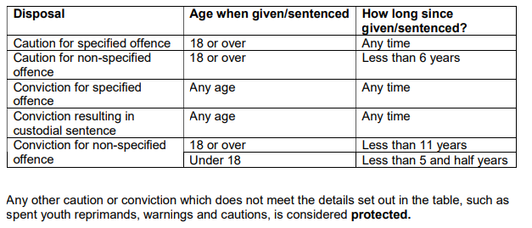

Declaration

With this application, I hereby consent to the information in this form being retained for recruitment, selection and employment related purposes. I understand that any offer of employment is subject to the relevant pre-employment checks including but not limited to satisfactory a) Verification of identity b) References, C) DBS Certificate and check of the barred list(s) (if applicable), d) Medical clearance e) Proof of eligibility to work in the UK f) Proof of qualifications and registrations. I declare that all statements I make in this application are true and, to the best of my knowledge and belief, that I have not withheld any relevant information. I understand that if I have made any false statements or omitted and information, I am liable to have my application rejected, or if appointed, liable to be dismissed.

Signature |  | Date

Referees
Please give the name and address of two people whom we may contact for a employment reference. One of these should be from your current or most recent place of employment, although the MAT reserves the right to contact any of your former employers.

*Please contact your referee prior to your application. To be compliant with UK data protection laws, including the GDPR, your referee may require your written permission to provide us with their reference. Not having this permission may slow down the recruitment process.

If you have previously been employed in education the Headteacher or Head of HR, from this establishment should be included.

Please only provide personal or character references if you cannot provide an employment reference, owing to not being employed previously employed.

In relation to work with children, we will seek information about any past disciplinary issues relating to children and/or child protection concerns you may have been subject to. If you have any concerns about this, please do not hesitate to contact our Human Resources Department.

References will be requested for shortlisted candidates prior to interview.

 | 1st Referee | 2nd Referee
Name
Job Title
Organisations
Relationship to you
Address
Tel. No
Fax. No
E-mail Address
*Have you given your permission to your referee to provide a reference? (see above)  Are you willing for this referee to be approached prior to interview? | Yes ☐ No ☐  Yes ☐ No ☐ | Yes ☐ No ☐  Yes ☐ No ☐

Please return your completed application by email to: HR Department via hr@covmat.org

If you are short listed for this post you will be required to sign your application form prior to interview.

