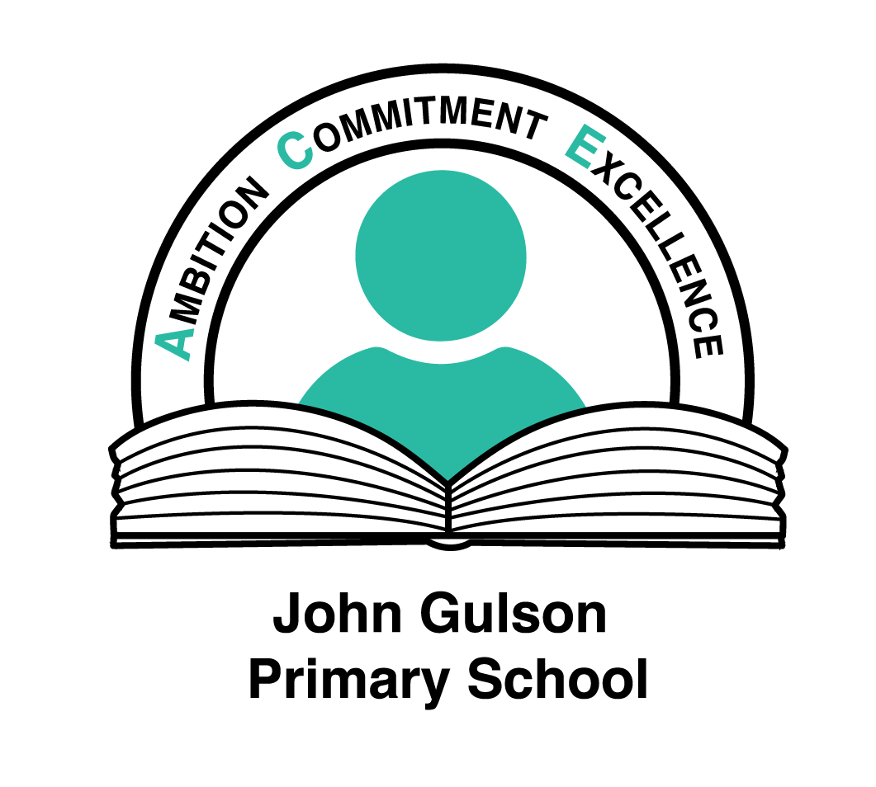

Class Teacher – TMS/UPS Job Description
The school is committed to inclusive policies and practice, ensuring equal opportunities for all pupils and staff regardless of race, gender or disability. We are also committed to safeguarding the welfare of our pupils

John Gulson Primary School is committed to policies of ensuring equal opportunities for pupils and staff, regardless of race, gender or disability. The active participation in the life of the school is to be encouraged. Teamwork is seen as the key to the school’s effectiveness and success. Members of the teaching staff will have a commitment to working collaboratively, supporting the work of colleagues in other phases or curriculum areas of the overall benefit of pupils.

This job description is for a class teacher working with pupils in the 3-11 age range, with a classroom responsibility for all contracted sessions.

- Teaching and Learning

The particular responsibilities attached to the teaching post are as follows:

- Contribute to raising the standard of teaching and learning through demonstrating excellent classroom practice
- Establish a safe environment, which supports learning and in which pupils feel secure and confident. Ensure effective teaching of whole classes, and of groups and individuals within the whole class setting, so that teaching objectives are met, and best use is made of available teaching time
- Set tasks which challenge and interest pupils, considering differentiation, relevance, progression, breadth and balance and coherence
- Select and make good use of ICT and other learning resources which enable teaching objectives to be met
- Provide feedback to pupils and ensure work is marked regularly in line with the school’s marking policy
- Complete records and make effective use of assessment information on pupil’s attainment and progress when teaching and planning future lessons; and report to parents on pupil progress
- Set high expectations for pupil’s behaviour, establishing and maintaining a good standard of discipline through well-focused teaching and through positive and productive relationships
- Ensure each child’s progress with regard to the schools stated Vision & Values. Seek opportunities to contribute to the quality of pupil’s broader education, including their personal, spiritual, moral, social and cultural development
- Be fully conversant with and use all school-based schemes of work and policies
- Be fully conversant with and use, all relevant curriculum documentation
- Set home learning opportunities for pupils in line with school policy
- Be fully conversant with, and adhere to, all stated policies with regard to health and safety
- Develop and update Individual Education Plans for children with Special Educational Needs
- Identify children that are more able and ensure that the curriculum is challenging enough to meet their needs
- To direct and work in partnership with support staff working in the classroom ensuring that they understand and carry out their role with pupils; and
- Attend, contribute to and lead staff meetings and discussions in order to ensure coherent planning and curriculum delivery.

- Curriculum Development

The postholder will lead an aspect of the curriculum or have wider school responsibilities commensurate with their professional experience and grade.

Summarily
The postholder will strive to be an effective and motivational professional who challenges and supports learners to do their best through:
- Inspiring trust and confidence
- Building team commitment
- Engaging and motivating pupils and colleagues
- Positive action to improve the quality of learning within the school

Other Duties
Any other duties and responsibilities within the range of the salary grade.
You are required to carry out such duties as the Headteacher may reasonably require from time to time. This job description may be amended after discussion.

The post holder must comply with Coventry City Council’s health and safety policy and in particular is required:-
- To take reasonable care for their own health and safety at work and of those who may be affected by their actions or by their omissions
- To cooperate with their line manager and senior management, to work safely, to comply with health and safety instructions and information and undertake appropriate health and safety training as required
- Not to intentionally or recklessly interfere with or misuse anything provided in the interests of health, safety and welfare
- To report to their manager any health and safety concerns, hazardous condition or defect in the health and safety arrangements.

Any further Health and Safety responsibilities relevant to this post will be set out in the offer letter and Written Statement of Particulars

The post holder must comply with the Interagency procedures of the Safeguarding Boards and Coventry City Council’s policies for safeguarding children and safeguarding adults and in particular is required:-
- To ensure they are aware of the signs that may suggest a child or vulnerable adult is being abused or neglected
- To report to their manager, or other appropriate manager, any concerns they may have that suggest that a child or vulnerable adult may be being abused or neglected immediately

Any further Safeguarding Board responsibilities relevant to this post will be set out in the offer letter and Written Statement of Particulars

Post holders will be accountable for carrying out all duties and responsibilities with due regard to the City Council's Equal Opportunities Policy.

Duties which include processing of any personal data must be undertaken within the corporate data protection guidelines.

Responsible for: To be negotiated with the successful candidate.

Responsible to: The Governing Body, Headteacher and Senior Leadership Team.

Date Reviewed: May 2020

