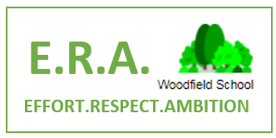

Classroom Teacher (SEMH)
MPS/UPS & SEN 1 Point



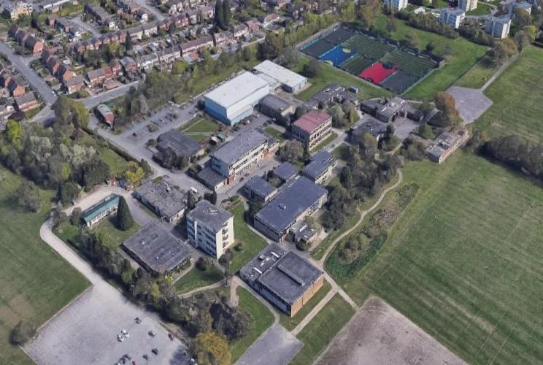

Woodfield School
Coventry

Woodfield School is seeking exceptional, empathetic, and innovative teachers who are passionate
about transforming the educational experiences of young people with Social, Emotional and
Mental Health (SEMH) needs. If you believe every child deserves a champion and are ready for a
truly rewarding challenge in one of the most exciting educational journeys in the country, we
want to hear from you!
Be the Teacher They Remember Forever!

Who are Woodfield School?

Woodfield is a specialist all-through SEMH school supporting children from Year 1 to Year 11 who have been identified as unable to manage or cope within mainstream settings due to their special educational needs, many of our children have also experienced significant trauma and adverse childhood experiences. Our school community provides not just education, but a safe space, a family-oriented community, and pastoral support for children and families who may have "given up" on education and are at crisis point.
We're at an exciting turning point in our journey:
We'll be relocating to a state-of-the-art facility at the old Woodlands site in November 2026
This will make us one of the largest and most innovative SEMH provisions in the country
We are creating the first-ever multi-agency approach to a school setting in collaboration with Social Care, Health and Police!

“I remember feeling ignored at my old school, there were so many kids and the teachers just ignored me. So, I had to do whatever I needed to get their attention. I don’t need to do that here.”
“I like to call my teacher my second mum”

Y2 Primary Pupil

Y4 Primary Pupil
“The staff at Woodfield saved my son and my family. I will always be grateful to them”

“I’ve had to ‘unlearn’ mainstream. I don’t need to fear the phone ringing from the school anymore.”

Woodfield Parent
Woodfield Parent
What will I be doing?
As an SEMH Teacher at Woodfield, you'll lead a class of up to 8 students supported by dedicated learning support staff who will form your Woodfield ‘delivery team’. You'll deliver engaging lessons while creating a therapeutic, personalised environment that supports student learning and regulation that you will design and run together!
What you'll be doing:
• Delivering high-quality, creative and adaptive teaching, bespoke to the needs of your students
• Creating a safe, nurturing classroom environment
• Developing positive relationships with children who may have previously had a poor experience of education
• Working as part of a delivery team to support the whole child
• Championing our school values: Effort, Respect, and Ambition
• Planning and implementing personalized approaches
• Building strong relationships with parents, carers, and external agencies

What We're Looking For
We need teachers who are:
• Qualified teachers (or soon to qualify)
• Passionate about making a difference to vulnerable young people
• Resilient, adaptable, and reflective practitioners
• Committed to inclusive education and removing barriers to learning
• Warm, caring, and positive with high expectations
• Willing to go the extra mile for children and accept no excuses for underachievement
Experience and Skills:
• A record of consistently good teaching
• Strong behaviour management skills
• Understanding of SEMH needs (or willingness to develop this knowledge)
• Ability to create engaging, imaginative learning environments
• Excellent communication skills with children, parents, and colleagues
The Role

Make a genuine difference in the lives of children who need it most. We are the only school of our type in Coventry!
No two days are the same - a varied, challenging, and rewarding role
Excellent training and development opportunities including potential pathways to HLTA or qualified teacher status. Many of our staff have gone from being LMs to Pastoral Managers, Teachers and even Senior Leaders!
Supportive and friendly team who understand the challenges and rewards of SEMH education. Become part of the Woodfield family!
Be part of our journey to create the very best SEMH provision in the country
Could you be part of the ‘Be more Woodfield’ movement? See our staff values below!
So, why join Woodfield?

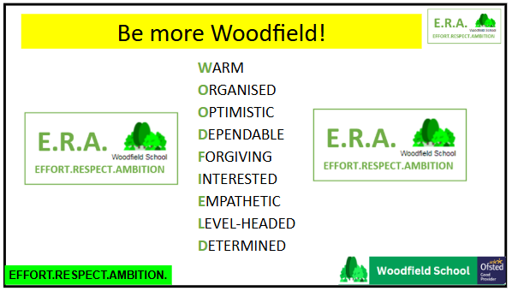

Safeguarding

Woodfield School is committed to safeguarding and promoting the welfare of children and young
people. All positions are subject to an enhanced DBS check and suitable references.


Don’t just take it from us! Hear from some of our current staff:
How can you join the journey?
This was
For further details, an application form, and to apply, please visit our website: www.woodfieldschool.net
For an informal discussion about the role, please contact:
Ben Hooper – Vice Principal at bhooper@woodfieldschool.net
Please return completed application forms to the HR recruitment team
Closing date: Sunday 4th October 2026
Interview date: To be confirmed
Join us on our mission to provide excellence in SEMH education for all our students!
“I love that we are aiming to level the field for the most disadvantaged young people”
“It’s like one big family! Every single person matters, students and staff”
“The staff around you are supportive and always check in on each other – I’ve made best friends
for life working here”
“I love seeing the change in the children I work with and the support all the staff give each other”
“No day is the same. Every day I go home with something that has made me smile or laugh. Staff
are lovely and pleasant to be around. It’s really rewarding to see the difference I make to the
children”
“Woodfield is a unique one of a kind school that is more than a classroom, it’s a community. We
have team that go above and beyond to support our children and families and our trauma
informed approach is one that is close to my heart and puts our children first”
“I love working with such amazing children, who make my days so special”
“The dedication, love and support of the team working tirelessly to improve the life chances of
the most vulnerable”

