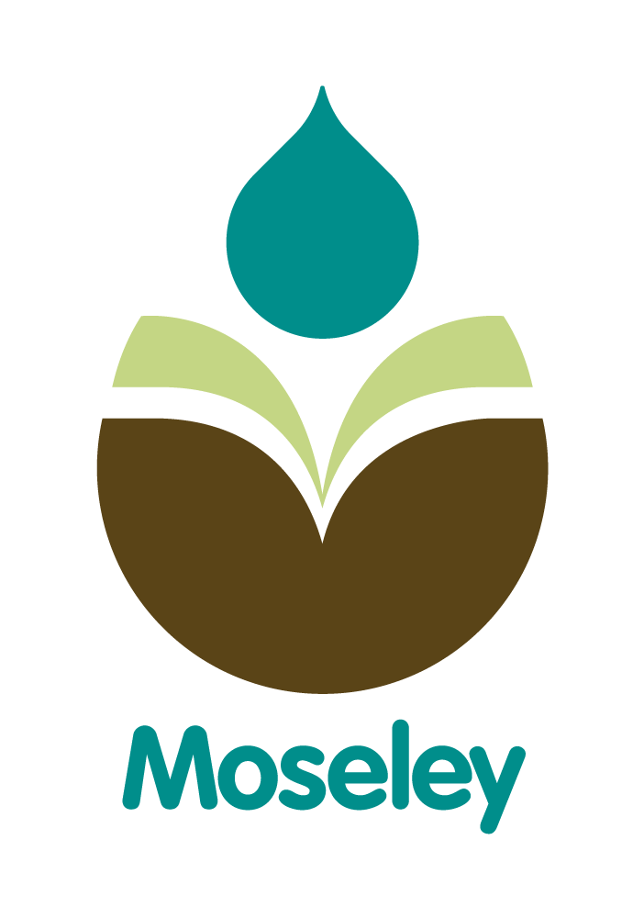

Moseley Primary School 2021

Moseley Primary School is situated in Coundon in Coventry about one mile west of the city centre. It occupies a large, very pleasant site with three playgrounds, a large playing field, a labyrinth, a trim trail, a Music Garden, an all weather pitch, a tyre park, a woodland area and a pond area. The building is very modern (we moved in for the start of the September term 2006). The building reflects our interest in environmental protection and we provide a high-quality working environment for both adults and children.

We are a 2 form entry school. We have 420 full time children and 50 part time children in Nursery and Dynamos.

About half of our children are from minority ethnic backgrounds and about 21% are Pupil Premium children. The school supports our EAL children, and those with special educational needs, extremely well. We have a very good level of in-house provision as well as support from external agencies. In many ways our catchment is broadly average. Our children attain below national averages on entry but achieve in line with the national at the end of KS2. Our value added score has been around 100 for the last five years.

The school’s leadership team will consist of a Headteacher, a Deputy Headteacher, two Assistant Headteachers, four senior teachers and a School Business Manager. Each member of staff takes responsibility for an area of the curriculum and belongs to a wider curriculum team.

The school is organised into learning teams as follows:

Learning Team 1 Dynamos, Nursery and 2 Reception classes
Learning Team 2 Four classes, 2 Yr1 & 2 Yr2
Learning Team 3 Four classes 2 Yr3 & 2 Yr4 classes
Learning Team 4 Four classes, 2 Y5 & 2 Yr6 classes

The teaching staff is supported by a Safeguarding Officer, a School Business Manager, Assistant Business Manager, Administrative Officer and Clerical Assistant, a site services officer, teaching assistants (some part-time), lunchtime supervisors and cleaners. In total the staff team totals around 75 people.

All teachers plan in collaboration with other members of their learning teams. We have undergone a review of the curriculum and we are pleased that it better meets the needs of our pupils. School has a strong emphasis on PSHE.

Governors are very supportive and play a key role in addressing the future direction of the school.

We have developed links with neighbouring primary and secondary schools and also with local universities (for joint projects and Initial Teacher Training). The school is keen to further develop partnership working and actively seeks to strengthen links with other agencies. We are part of the Compass Network of schools.

We have a good working relationship with parents. They are welcomed into school and encouraged to work in partnership with us to support their child’s education.

The school was inspected by OFSTED in June 2018 was confirmed as Good. Please see the OFSTED website for the full report.


